Graphical Processing Systems
Meeting OpenGL
Zavaczki Peter – 30433

Table of contents

- Table of contents
- Subject specification
- Scenario
  - Scene and objects description
  - Functionalities
- Implementation details
  - Functions and special algorithms
  - Graphics model
  - Data structures
  - Class hierarchy
- Graphical user interface presentation / user manual
- Conclusions and further developments
- Reference

Subject specification
The aim of the project is simulating a 3D game in a small scene of objects presenting a range of features, such as:
- visualization of the scene: scaling, translation, rotation, camera movement
using keyboard and mouse
using animation
- specification of light sources (minimum two different lights)
- viewing solid, wireframe objects, polygonal and smooth surfaces
- texture mapping and materials, textures mapping on objects
- exemplify shadow computation
- exemplify animation of object components
- photo-realism, scene complexity, detailed modeling, algorithms development and implementation (objects generation, collision detection, shadow generation, fog, rain, wind), animation quality, different types of light sources (global, local, spotlights)

These would all be implemented with the help of OpenGL 4.4 and Visual Studio 2017

Scenario

Scene and objects
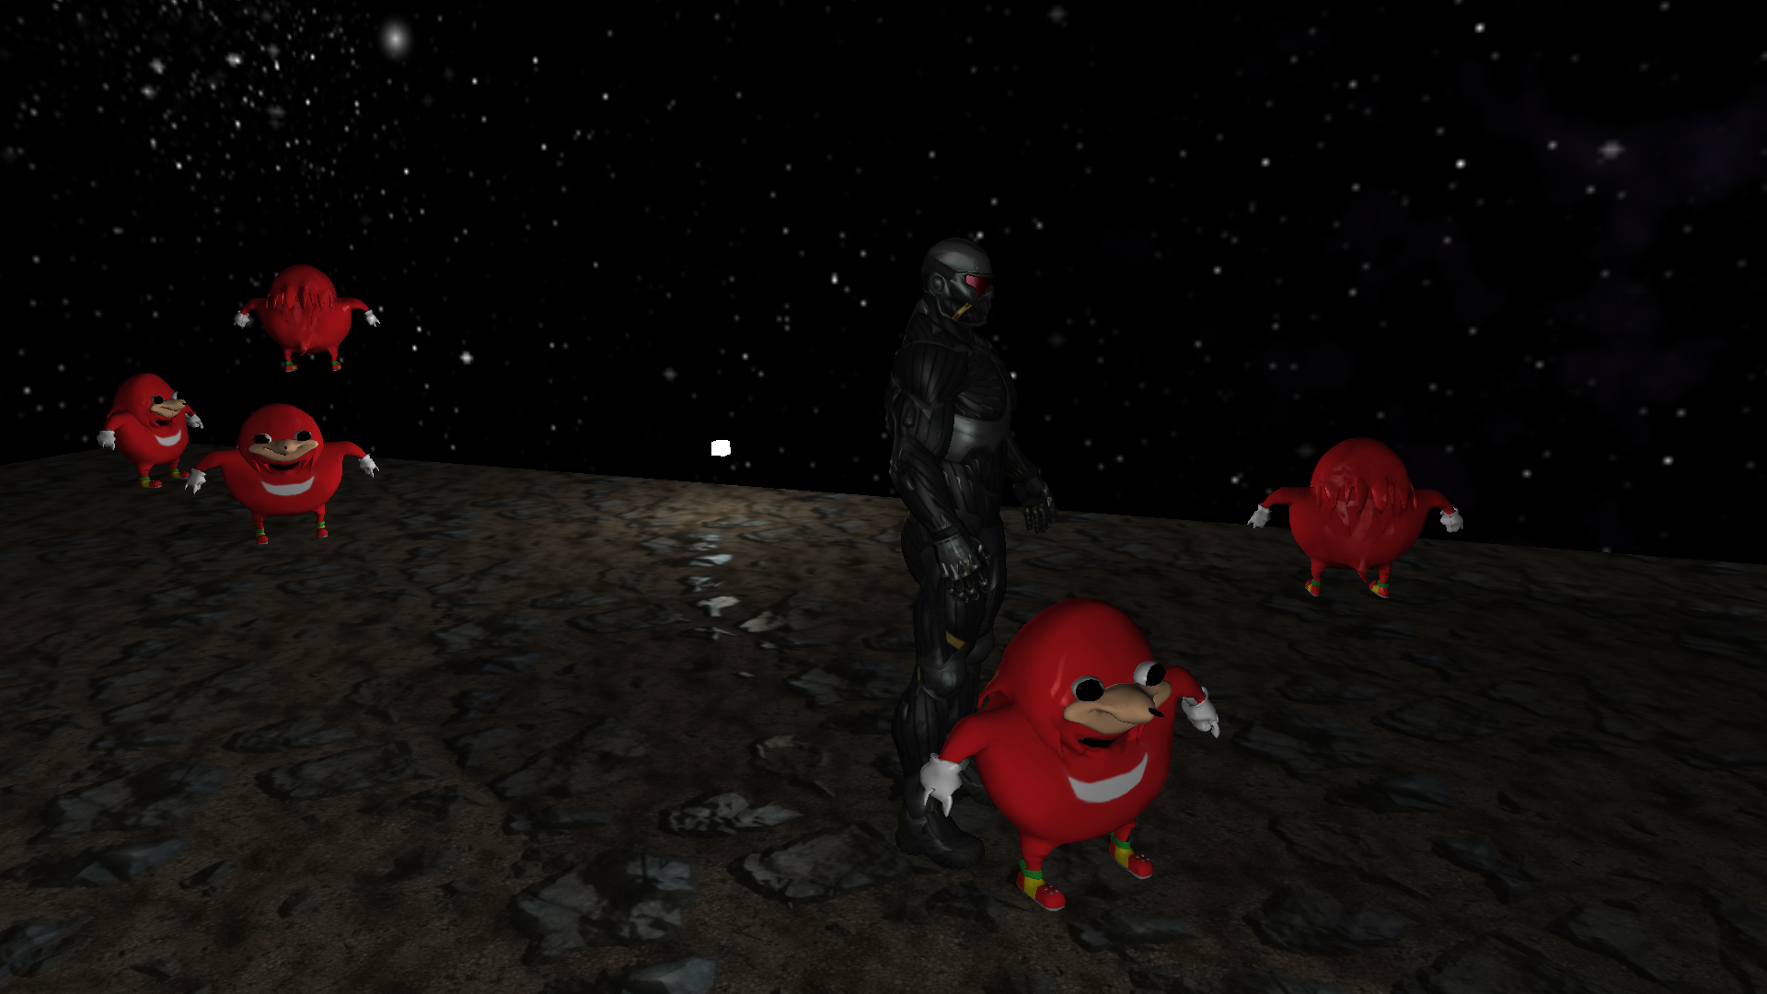
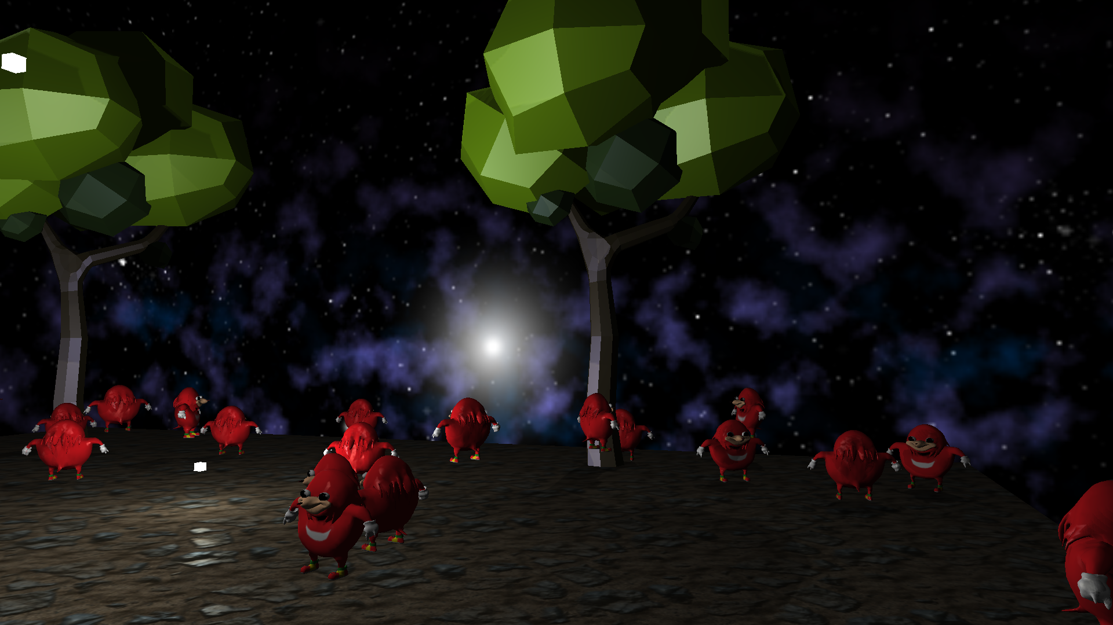
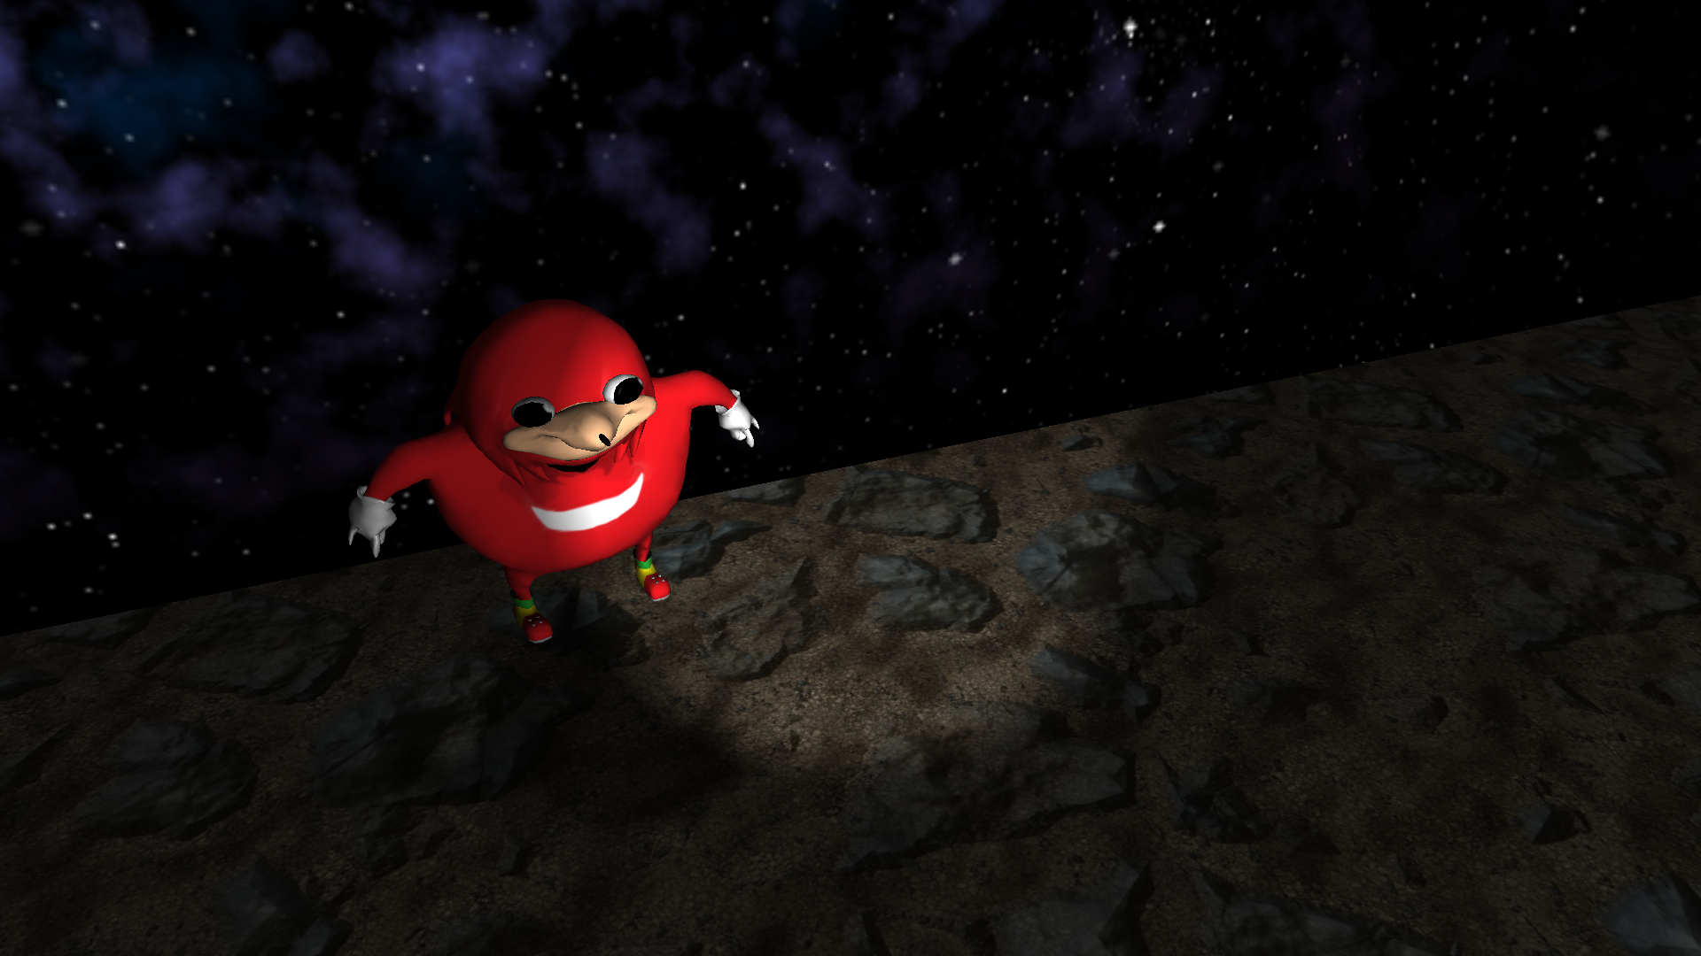

Functionalities

The user interaction implemented is quite simple. The user can be view the scene by walking around using the WASD keys with the aid of the mouse for the yaw and pitch position of the camera. The “F” button activates a spotlight with a flashlight effect. The “B” button switches between Blinn-Phong and Phong shading techniques. The “P” button switches between filled polygonal viewmode and wireframe viewmode.
Other object functionalities, although not affected by the user, are the animations. Some of the knuckles characters jump, some rotate, some jump and rotate. Lighting is implemented using a directional light, a toggleable spotlight and 3 point lights. Shadows are cast by the directional light only.

Implementation details

Functions and special algorithms
There are 2 initialising functions for the window created, and for the OpenGL state, created in an attempt to modularize the code. Other than that there are a couple of callback functions that explain how some events should be handled such as processing a keyboard input (Esc to exit, WASD for camera). As texture loading would be quite spacious, there have also been created separate functions for this purpose. A sepparate function has been defined for loading all the light sources into the shader, and rendering the scene, including all the animations. A final function helps in loading a cubemap texture for the skybox.
The reason for such an approach, although it might not be the most effective, is that it eases the understanding of how OpenGL works which suits the educational purpose of this project.

Graphics model
The objects used here were taken from different sources, the nanosuit is from the learnopengl.com page, the knuckles model is from deviantart and the tree is from free3d.com. The nanosuit model is standalone, while the trees and knuckles are grouped.

Data Structures
The unusual data structures used in this project are the ones representing the point lights, the spotlight and the directional light in the shaders, each having its specific structure. There is a structure used by the Assimp library which made it possible for the 3D models to be loaded successfully. Simplified, it would look like this:
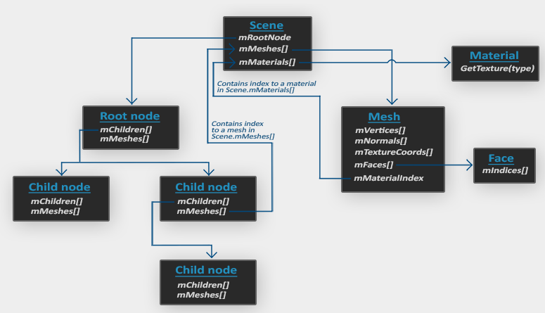

Class hierarchy
There are 4 classes used in this project: Model, Mesh, Shader, and Camera.
The Camera class is usefulby helping us create the “camera object” with which the user gets the first person view inside the world.
The Shader class is necessary to simplify loading, updating, and overall using the OpenGL programmable shaders without making the code difficult to read.
The Model and Mesh classes come in when the need to import 3D models. They use the Assimp external library to fulfill their functions. The model class takes several meshes which are parts of an object and successfully links them together in order to have the model displayed on the screen.

GUI Presentation. User manual.
The project can be run by opening it in Visual Studio 2017 IDE and running it or running the compiled executable.
-Esc to quit the game
-WASD + Mouse movement to move/look around (please note that the user camera is always grounded, and thus “flying around” is not possible)
-”B” to switch between Blinn-Phong or Phong shading
-”F” to enable/disable the flashlight
-”P” to switch between filled polygonal view or wireframe view

Conclusions and further developments
The project exemplifies the power lying within OpenGL, usable for creating visually complex and realistic scenes.
There are some things which would certainly benefit from further developments or changes, such as adding more objects, creating shadows cast by point lights and blending them together, adding object collision, etc.

References
- https://learnopengl.com/
- https://tidiestflyer.deviantart.com/art/The-Knuckles-meme-as-a-3d-model-704695335
- https://free3d.com/
- http://cgis.utcluj.ro/teaching/course/view.php?id=5

